9.90: a) In the case that no energy is lost, the rebound height 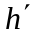 is related to the speed by 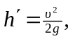and with the form for h given in Example 9.9, 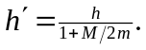 b) Considering the system as a whole, some of the initial potential energy of the mass went into the kinetic energy of the cylinder. Considering the mass alone, the tension in the string did work on the mass, so its total energy is not conserved.

